SIMATS ENGINEERING
ASSESSMENT TOOL 1

COURSE NAME: Database Management Systems
COURSE CODE: CSA0501

COURSE OUTCOME COVERED
CO1: Analyze DBMS architecture, different data models, schema types, and design
ER/EER diagrams, relational schemas for case-based scenarios by identifying
entities and relationships. (BL1, BL2)

Activity Tool : Short Answer Text(High)
Assessment Tool Weightage: 30%

- UPS Product Tracking Information System – ER Diagram (DBMS)
Entities and Attributes
1. SHIPPED_ITEM
Primary Key: Item_Number
Attributes:
- Item_Number (PK)
- Weight
- Dimensions
- Insurance_Amount
- Destination
- Final_Delivery_Date

2. RETAIL_CENTER
Primary Key: RetailCenter_ID
Attributes:
- RetailCenter_ID (PK)
- Type
- Address

3. TRANSPORTATION_EVENT
Primary Key: Schedule_Number
Attributes:
- Schedule_Number (PK)
- Type (Flight/Truck)
- Delivery_Route

Relationships
1. RECEIVED_AT
- Relationship: Retail Center receives Shipped Item
- Cardinality:
  - One Retail Center → Many Shipped Items (1:M)
  - Each shipped item is received at only one retail center.
RETAIL_CENTER (1) ─────< RECEIVED_AT >───── (M) SHIPPED_ITEM

2. TRANSPORTED_BY
- Relationship: Shipped Item is transported through Transportation Events
- Cardinality:
  - Many Shipped Items ↔ Many Transportation Events (M:N)
  - A shipped item can travel through one or more transportation events.
  - A transportation event can carry many shipped items.
SHIPPED_ITEM (M) ─────< TRANSPORTED_BY >───── (M) TRANSPORTATION_EVENT

ER Diagram (Text Representation)
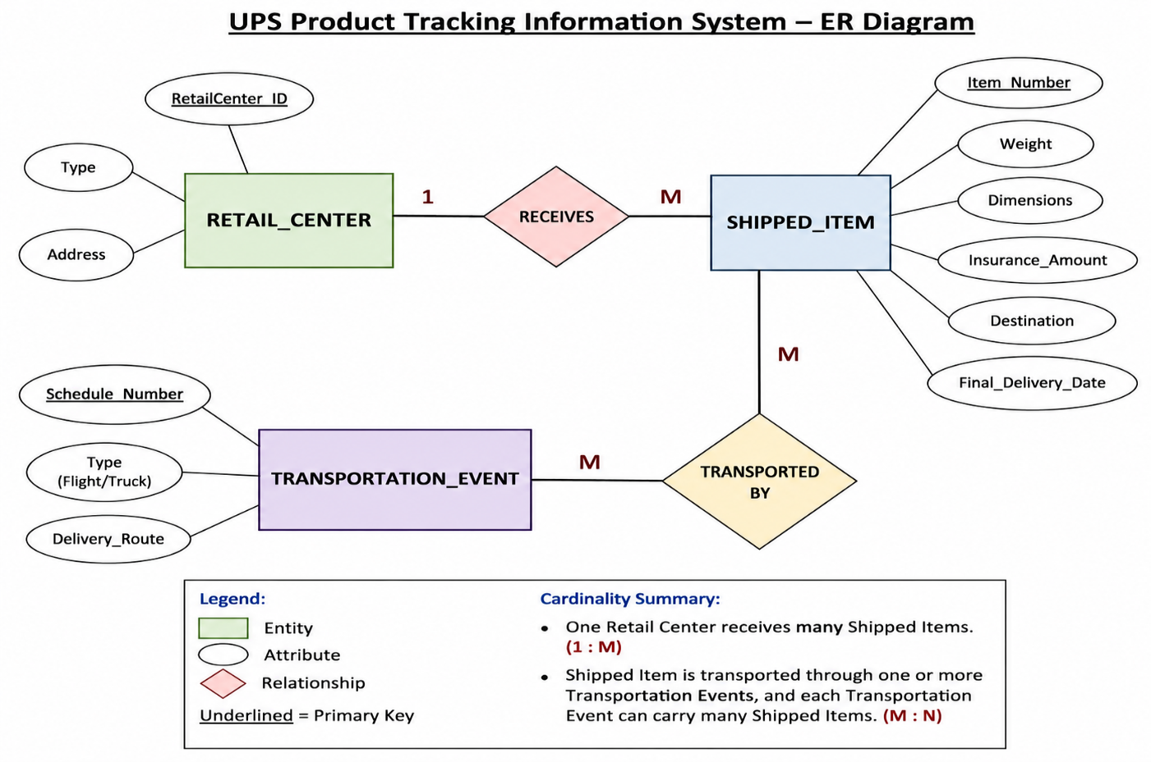

Cardinality Summary
Entity 1 | Relationship | Entity 2 | Cardinality
Retail Center | Receives | Shipped Item | 1 : M
Shipped Item | Transported By | Transportation Event | M : N

2.) Course Management System – Theory Answer (DBMS)
Answer:
The Course Management System is designed to schedule classrooms for final examinations in a university. Instead of representing all information in a single EXAM entity, the database is normalized by introducing separate entities for COURSE, SECTION, and ROOM. This reduces redundancy and improves data management.
Entities and Attributes
1. COURSE (Strong Entity)
- Primary Key: c-number
- Attributes:
  - c-number (PK)
  - Name
  - Department
2. SECTION (Weak Entity)
- Partial Key: s-number
- Attributes:
  - s-number (Partial Key)
  - Enrollment
Reason:
A section cannot exist without a course. Therefore, SECTION is modeled as a weak entity and depends on COURSE.
3. ROOM (Strong Entity)
- Primary Key: r-number
- Attributes:
  - r-number (PK)
  - Capacity
  - Building
4. EXAM (Relationship)
The exam scheduling information is represented through a relationship among COURSE, SECTION, and ROOM.
Attributes of Exam:
- Course-name
- Section-number
- Room-number
- Time

Relationships
1. COURSE — HAS — SECTION
- Cardinality: 1 : N
- One course can have many sections.
- Each section belongs to only one course.
2. SECTION — SCHEDULED_EXAM — ROOM
- Cardinality: M : N
- Many sections can be scheduled in many rooms.
- Each exam is conducted in one room at a specified time.

Cardinality
Entity | Relationship | Entity | Cardinality
COURSE | Has | SECTION | 1 : N
SECTION | Scheduled in | ROOM | M : N

Advantages of this Design
- Eliminates data redundancy.
- Maintains data integrity.
- Supports multiple sections for a course.
- Allows efficient scheduling of examination rooms.
- Makes the database easier to maintain and update.

Conclusion
The E-R model consists of three entity sets: COURSE, SECTION, and ROOM. The SECTION entity is modeled as a weak entity because it depends on the COURSE entity for identification. The SCHEDULED_EXAM relationship connects SECTION and ROOM and stores the examination time. This design efficiently represents the university's final examination scheduling system.
ER DAIGRAM:
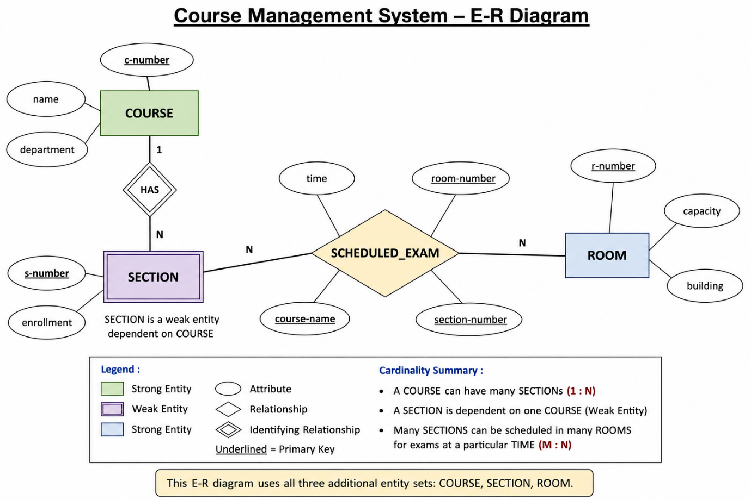

3.) Explanation of the ER Model
- Courses
  - Attributes: Course No, Title, Credits, Syllabus, Prerequisites
  - Relationship: Offered As → Course Offering
- Course Offering
  - Attributes: Year, Semester, Section No, Classroom, Timing
  - Relationship: Taught By → Instructor
- Instructors
  - Attributes: Instructor ID, Name, Department, Title
- Students
  - Attributes: Student ID, Name, Program
  - Relationship: Enrolled In → Course Offering
- Enrollment
  - Connects Students ↔ Course Offering
  - Attributes: Grade, Marks
This ER diagram models the registrar’s office system by capturing:
- Courses and their offerings per semester/year
- Instructors teaching specific offerings
- Students enrolling in offerings
- Grades awarded through the Enrollment relationship
ER DAIGRAM :

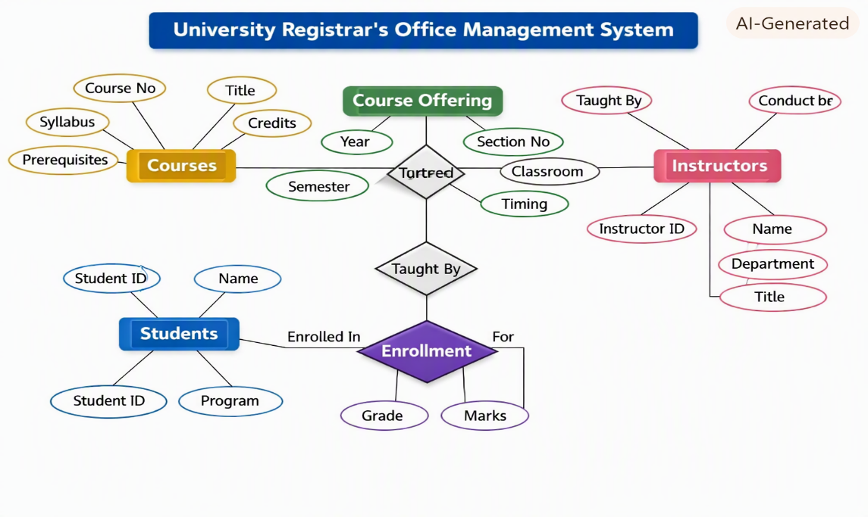
4.) Entities and Relationships
- Patient
  - Attributes: SS#, Name, Insurance
  - Relationship: Undergoes → Test Log
  - Relationship: Treated By → Physician
- Physician
  - Attributes: Name, Specialization
  - Relationship: Treated By → Patient
- Test Log
  - Attributes: SS#, Test Name, Date, Time
  - Relationship: Undergoes → Patient
- Doctor–Patient
  - Attributes: Physician Name, SS#
  - Relationship: Links → Physician ↔ Patient
- Patient History
  - Attributes: SS#, Test Name, Date
  - Relationship: Has History → Patient
📋 Corresponding Tables
Table Name | Attributes | Primary Key | Foreign Key
Patient | SS#, Name, Insurance | SS# | —
Physician | Name, Specialization | Name | —
Test_Log | SS#, Test_Name, Date, Time | (SS#, Test_Name, Date) | SS# → Patient
Doctor_Patient | Physician_Name, SS# | (Physician_Name, SS#) | Physician_Name → Physician, SS# → Patient
Patient_History | SS#, Test_Name, Date | (SS#, Test_Name, Date) | SS# → Patient

This model captures the hospital’s workflow:
- Each patient is treated by one or more physicians.
- Each test log records examinations for a patient.
- The doctor–patient table maintains treatment relationships.
- The patient history table keeps a chronological record of tests.
ER DAIGRAM:
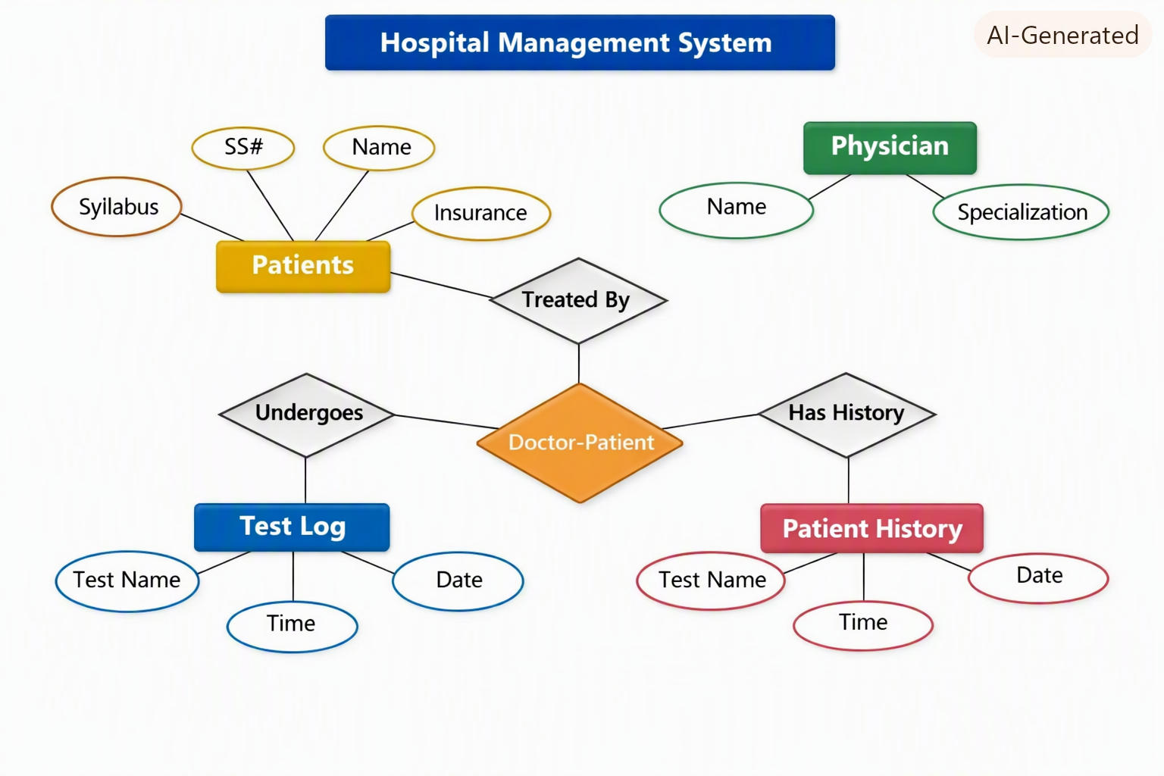
5.) Entities and Relationships
- Department
  - Attributes: Dept Name, Location, Manager Start Date
  - Relationship: Manages → Employee
  - Relationship: Controls → Project
- Project
  - Attributes: Project Name, Project Number, Project Location
  - Relationship: Controlled By → Department
  - Relationship: Worked On → Employee
- Employee
  - Attributes: SSN, Name, Address, Salary, Sex, Birth Date
  - Relationship: Assigned To → Department
  - Relationship: Works On → Project (with Hours/Week)
  - Relationship: Supervises → Employee (self-relation)
  - Relationship: Has Dependents → Dependent
- Dependent
  - Attributes: Dependent Name, Birth Date, Relationship
📋 Corresponding Tables
Table Name | Attributes | Primary Key | Foreign Key
Department | Dept_Name, Location, Manager_SSN, Manager_Start_Date | Dept_Name | Manager_SSN → Employee
Project | Proj_Name, Proj_Number, Proj_Location, Dept_Name | Proj_Number | Dept_Name → Department
Employee | SSN, Name, Address, Salary, Sex, Birth_Date, Dept_Name, Supervisor_SSN | SSN | Dept_Name → Department, Supervisor_SSN → Employee
Works_On | SSN, Proj_Number, Hours_Per_Week | (SSN, Proj_Number) | SSN → Employee, Proj_Number → Project
Dependent | SSN, Dep_Name, Birth_Date, Relationship | (SSN, Dep_Name) | SSN → Employee

This model captures the company’s organizational structure:
- Departments manage projects and have managers.
- Employees belong to departments, work on projects, and may supervise others.
- Dependents are linked to employees for insurance tracking.
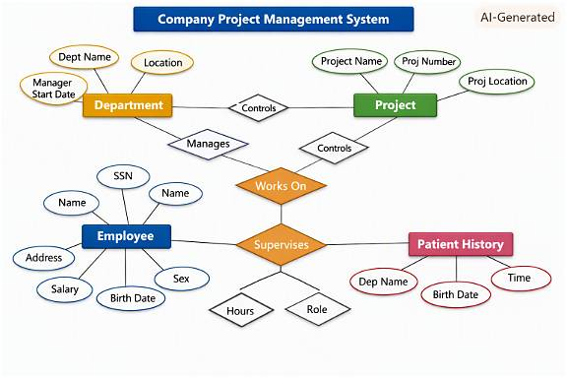
6.) Schema and Instance
Schema
- Definition: Schema is the structure or blueprint of a database. It defines how data is organized — the tables, fields, relationships, constraints, and data types.
- Example:
text
Student(SID, Name, Dept, Age)
This schema defines the structure of the Student table — what attributes exist and their types.
Instance
- Definition: Instance is the actual data stored in the database at a particular moment. It changes frequently as records are added, updated, or deleted.
- Example:
text
SID | Name | Dept | Age
101 | Arjun | CSE | 20
102 | Priya | ECE | 21
This is an instance of the Student table at a specific time.
🧠 Types of Schemas
Type | Description | Example
Logical Schema | Describes the logical design — tables, relationships, constraints, and data types. It focuses on how data is logically stored and connected. | Defines tables like Student, Course, Enrollment and their relationships.
Physical Schema | Describes the physical storage — how data is stored on disk, indexing, partitioning, and access paths. | Specifies file organization, indexes, and storage blocks for the Student table.
View Schema | Defines user views — subsets or virtual tables derived from the logical schema for specific users or applications. | A view showing only Name and Dept from Student for faculty access.
🧾 Summary
- Schema → Database design (structure).
- Instance → Actual data at a given time.
- Logical Schema → Conceptual design.
- Physical Schema → Storage-level design.
- View Schema → Customized user-level view.

7.) 🏦 Entities and Attributes
Entity | Attributes | Description
Customer | Customer_ID, Name, Address, Phone, Email | Represents people who hold accounts or take loans.
Account | Account_No, Type, Balance, Open_Date | Each customer can have one or more accounts.
Loan | Loan_ID, Amount, Type, Issue_Date, Interest_Rate | Represents loans taken by customers.
Branch | Branch_ID, Branch_Name, Location | Represents different branches of the bank.
Employee | Emp_ID, Name, Position, Salary | Represents staff working in branches.
Transaction | Trans_ID, Date, Amount, Type (Deposit/Withdrawal), Account_No | Records all account transactions.
🔗 Relationships
Relationship | Connected Entities | Description
Owns | Customer ↔ Account | A customer owns one or more accounts.
Applies_For | Customer ↔ Loan | A customer can apply for multiple loans.
Operates | Employee ↔ Account | Employees manage or operate customer accounts.
Works_In | Employee ↔ Branch | Each employee works in one branch.
Located_At | Branch ↔ Account | Accounts are maintained at a specific branch.
Performs | Account ↔ Transaction | Transactions are performed on accounts.
🧩 ER Diagram Structure
The ER diagram (as shown in the image) includes:
- Entities: Customer, Account, Loan, Branch, Employee, Transaction
- Relationships: Owns, Applies_For, Operates, Works_In, Located_At, Performs
- Cardinalities:
  - One Customer → Many Accounts
  - One Account → Many Transactions
  - One Branch → Many Employees
  - One Employee → Many Accounts
📋 Example Tables

Table | Attributes | Primary Key | Foreign Key
Customer | Customer_ID, Name, Address, Phone, Email | Customer_ID | —
Account | Account_No, Type, Balance, Open_Date, Customer_ID, Branch_ID | Account_No | Customer_ID → Customer, Branch_ID → Branch
Loan | Loan_ID, Amount, Type, Issue_Date, Interest_Rate, Customer_ID | Loan_ID | Customer_ID → Customer
Branch | Branch_ID, Branch_Name, Location | Branch_ID | —
Employee | Emp_ID, Name, Position, Salary, Branch_ID | Emp_ID | Branch_ID → Branch
Transaction | Trans_ID, Date, Amount, Type, Account_No | Trans_ID | Account_No → Account

8.) Extended ER (EER) Model
The EER model is an enhancement of the traditional Entity–Relationship (ER) model. It introduces advanced concepts to represent more complex relationships and constraints in real-world applications.
It extends ER with:
- Generalization
- Specialization
- Aggregation
🔑 Concepts
1. Generalization
- Definition: A process of abstracting common features from multiple entities and creating a higher-level, generalized entity.
- Example:
  - Entities: Car, Bike, Truck
  - Generalized Entity: Vehicle (with common attributes like Registration_No, Owner, Model).
- Use: Reduces redundancy by grouping shared attributes.
2. Specialization
- Definition: The opposite of generalization. It creates subclasses of an entity based on distinguishing characteristics.
- Example:
  - Entity: Employee
  - Specialized Entities: Manager, Engineer, Clerk
  - Each subclass has specific attributes (e.g., Manager → Bonus, Engineer → Skill).
- Use: Adds detail by differentiating entities.
3. Aggregation
- Definition: A higher-level abstraction where a relationship itself is treated as an entity.
- Example:
  - Relationship: Works_On between Employee and Project
  - Aggregation: Assignment entity that represents the relationship, with attributes like Hours_Per_Week.
- Use: Useful when relationships need attributes or when relationships participate in other relationships.
📊 Summary Table
Concept | Direction | Purpose | Example
Generalization | Bottom → Top | Combine common features | Car, Bike → Vehicle
Specialization | Top → Bottom | Create subclasses | Employee → Manager, Engineer
Aggregation | Relationship → Entity | Treat relationship as entity | Works_On → Assignment

9.) Entities and Attributes
- Hospital
  - Attributes: Hospital_ID, Name, Location
- Person (Superclass)
  - Attributes: Person_ID, Name, Address, Contact
  - Inheritance: Specialized into Doctor, Patient, Nurse, Staff
- Doctor (Subclass of Person)
  - Attributes: Specialization, Salary
- Patient (Subclass of Person)
  - Attributes: Patient_ID, Disease, Admission_Date
- Nurse (Subclass of Person)
  - Attributes: Duty_Shift
- Staff (Subclass of Person)
  - Attributes: Role
- Treatment (Weak Entity)
  - Attributes: Treatment_ID, Description, Date
  - Dependent on Patient (identified by Patient_ID + Treatment_ID)
- Prescription (Weak Entity)
  - Attributes: Prescription_ID, Medicine_Name, Dosage
  - Dependent on Treatment
- Room
  - Attributes: Room_No, Type, Capacity
- Appointment
  - Attributes: Appointment_ID, Date, Time
  - Relationship: Patient ↔ Doctor
🔗 Relationships
- Admitted_In → Patient ↔ Room
- Treats → Doctor ↔ Patient
- Has_Treatment → Patient ↔ Treatment (weak entity)
- Has_Prescription → Treatment ↔ Prescription (weak entity)
- Schedules → Doctor ↔ Appointment ↔ Patient
📊 Key EER Concepts Used
- Inheritance (Specialization):
  - Person generalized into Doctor, Patient, Nurse, Staff.
- Weak Entities:
  - Treatment depends on Patient.
  - Prescription depends on Treatment.

10.) 🎯 Role of a DBA
A Database Administrator (DBA) is responsible for the installation, configuration, maintenance, and security of a database system. They ensure that data is available, consistent, secure, and efficiently managed for users and applications.
🛠️ Key Responsibilities of a DBA
1. Database Design & Implementation
- Define database schemas, tables, indexes, and relationships.
- Ensure normalization and efficient data modeling.
2. Installation & Configuration
- Install database software (e.g., Oracle, MySQL, SQL Server).
- Configure parameters for optimal performance.
3. Performance Monitoring & Optimization
- Monitor query performance and system load.
- Use indexing, partitioning, and tuning techniques to improve speed.
4. Backup & Recovery
- Schedule regular backups.
- Implement disaster recovery plans to restore data in case of failure.
5. Security Management
- Control user access with roles and privileges.
- Protect against unauthorized access and SQL injection attacks.
6. Data Integrity & Consistency
- Enforce constraints (primary keys, foreign keys).
- Ensure ACID properties (Atomicity, Consistency, Isolation, Durability).
7. User Support & Maintenance
- Assist developers and analysts with queries.
- Apply patches and upgrades to keep systems up-to-date.
8. Capacity Planning
- Forecast future storage and performance needs.
- Scale databases as the organization grows.
📊 Example Scenario
- In a hospital system, the DBA ensures that patient records are always available, secure, and recoverable in case of system crashes.
- In a banking system, the DBA guarantees transaction consistency and prevents unauthorized access to customer accounts.

